ACTIVITIES FOR
THE SORCERER’S TOWER
by Ian Irvine
Illustrated by DM Cornish

The Sorcerer’s Tower
The orphan Tamly and his best friend Kym are as different as fire and snow. Kym has magic coming out of her fingers, and Tamly has none at all.
Their village is attacked by two evil sorcerer brothers, Harshax and Krushax, who are trying to steal its magic. And only Tamly, Kym and their friend Mel can save the village, and thwart the sorcerers’ evil plan.

Illustrations © DM Cornish 2008 from The Sorcerer’s Tower quartet © Ian Irvine 2008, 2017. Omnibus edition published by Christmas Press, 2017.

ACTIVITY 1
Tamly, Kym and Mel are shown in the three following pictures. Look at the pictures then write your own story:
- What do the evil sorcerers Harshax and Krushax do?
- How do Tamly, Kym and Mel beat them?
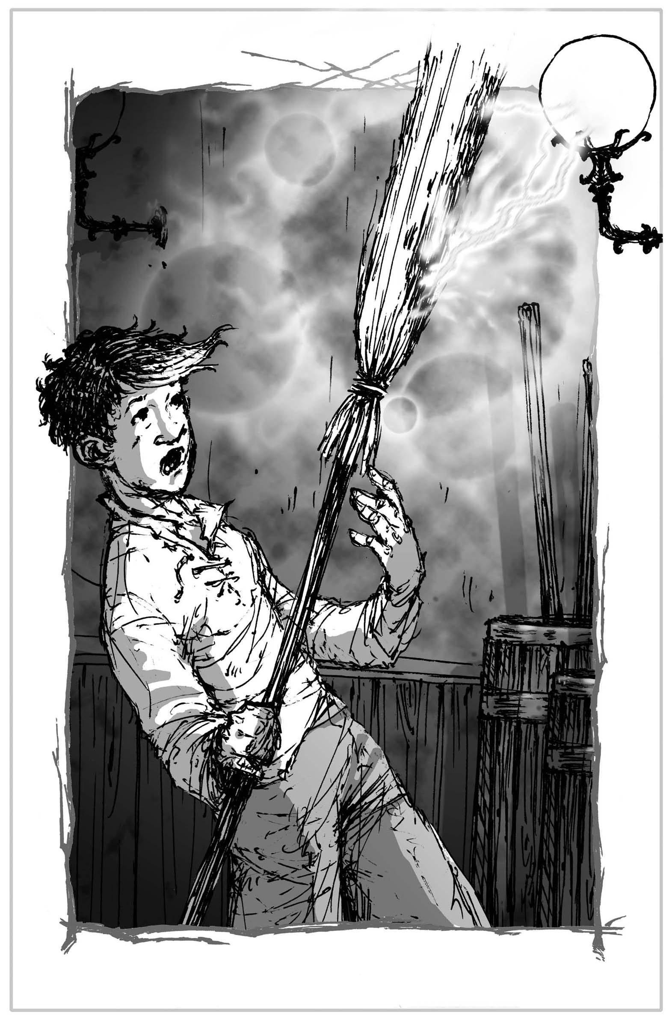

Here is Tamly.
He’s the only kid in the village who can’t do magic. He’s brave but clumsy and everything he does goes wrong.

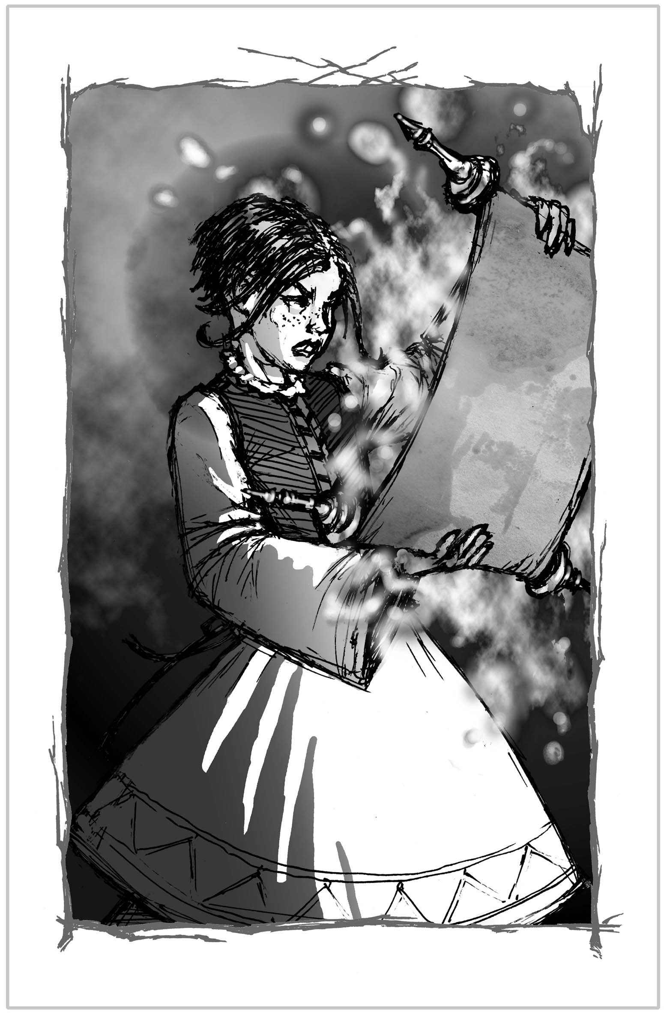

This is Kym.
She has oodles of magic but she’s really reckless and always getting into trouble.

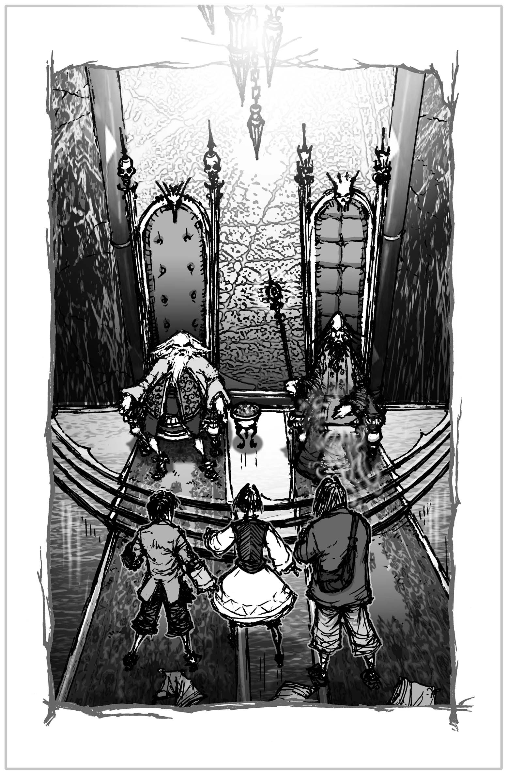
Tamly, Kym and Mel face the evil sorcerer brothers, Harshax and Krushax.

ACTIVITY 2
In Book 1, Thorn Castle, poor Kym is caught by Harshax and turned into a giant slug. And she really hates slugs. What does Tamly do (after he stops laughing)?
Write a funny short story about what happens next.

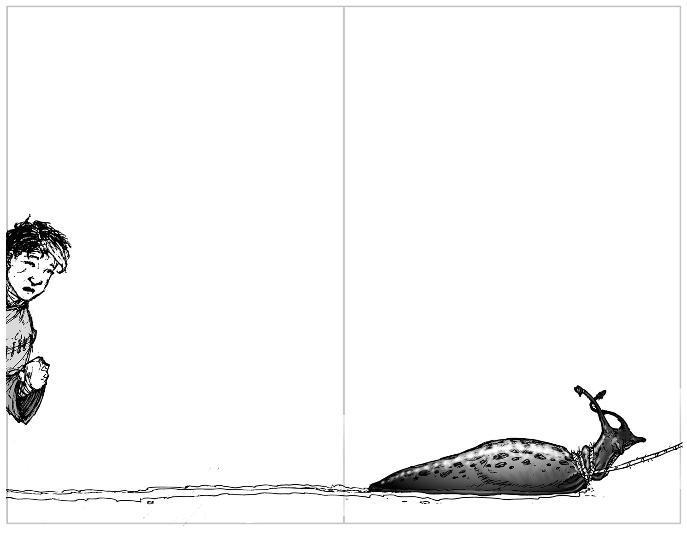

ACTIVITY 3
Watch Ian reading from Book 2, Giant’s Lair. Tamly and Mel have to try and rescue Kym from the giant’s cave at the top of the mountain? A cave that’s guarded by the gigantic, terrifying rukh.
Tell this scary but exciting story aloud.

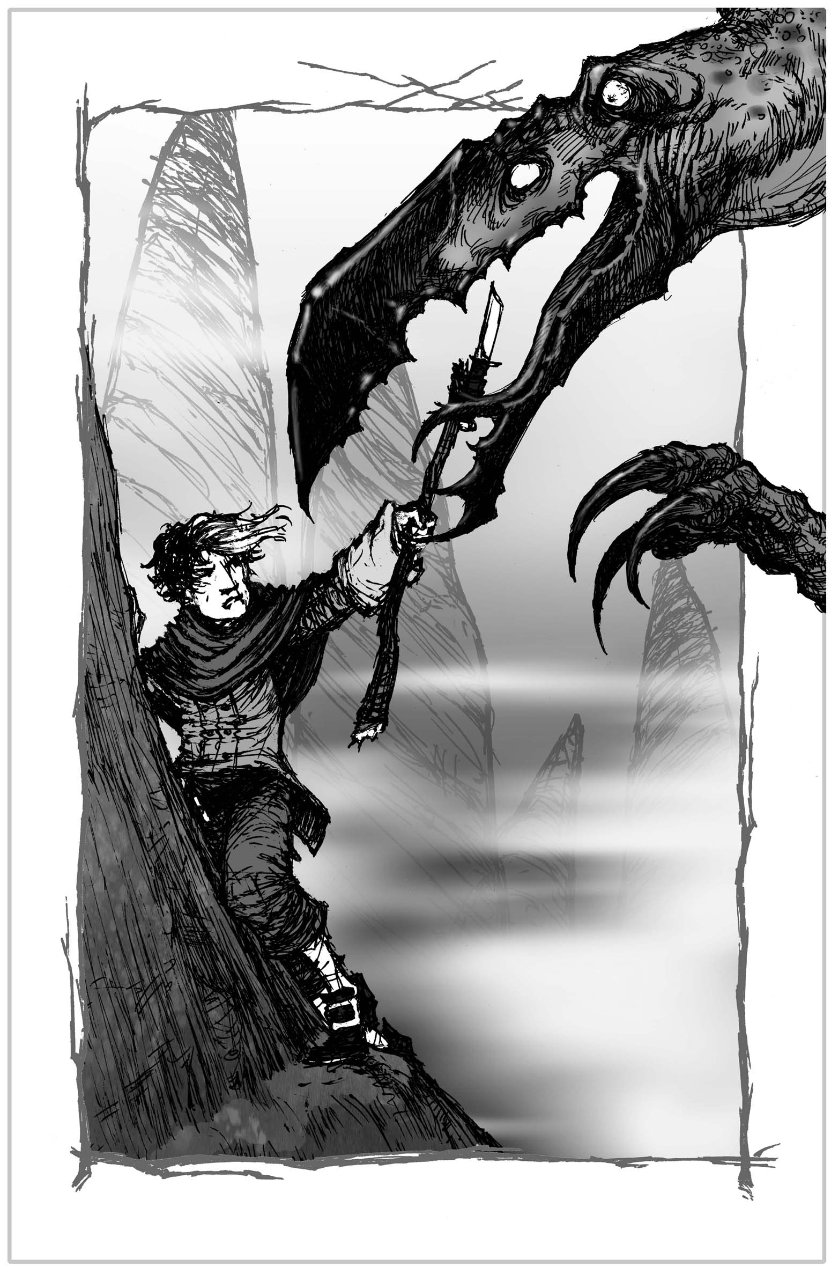

ACTIVITY 4
Tamly is abducted by the sorcerers Harshax and Krushax in a magical flying sled because they need his help to raise their wicked ancestor, the sorcerer Shardax, from the dead.
But why do they want Tamly when he can’t do any magic? What’s so special about him?
Can you think of a really clever and unusual way for Kym and Mel to save him and stop Shardax from ruining everything?

